**SOURCE CODE** :-

#include<iostream.h>

#include<conio.h>

#include<stdio.h>

#include<string.h>

#include<process.h>

#include<stdlib.h>

#include<graphics.h>

#include<dos.h>

void page1(void);

void page2(void);

void page3(int);

void med(int,int);

void doc(int,int);

void cancer(int);

void heart(int);

void respiratory(int);

void diabetes(int);

void fever(int);

void cough(int);

void cold(int);

void infection(int);

int op3;

int main()

{

clrscr();

page1();

getch();

return 0;

}

void page1()

{

char name[20],pass[20];

char oname[20]="admin";

char opass[20]="med";

int a,b;

cout<<"\n";

cout<<"\t \t \t ----------------------";

cout<<"\n \t \t ";

delay(100);

textcolor(18);

cprintf("| WELCOME TO MEDCITY |");

cout<<"\7 \n \t \t \t ----------------------";

delay(1000);

textcolor(12);

cout<<"\a\n\n\n\n\b\b\b\b\b\b\b\b\b\b\b\b\b\b\b\b\b";

cprintf("\n\n\n VERIFY YOUR AUTHENTICATION TO ENTER INTO WEBSITE");

cout<<"\n\n";

cout<<"\n \t \t \t -------------------------------\n ";

textcolor(22);

cprintf(" |ENTER USER NAME: ");

cin>>name;

cout<<"\n \t \t \t -------------------------------\n";

cout<<"\n \t \t \t -------------------------------\n ";

textcolor(22);

cprintf(" |ENTER PASSWORD: ");

cin>>pass;

cout<<"\n \t \t \t -------------------------------\n";

int i=0;

while(name[i]!=NULL || oname[i]!=NULL)

{

if(oname[i]==name[i])

a=1;

else

a=0;

i++;

}

i=0;

while(opass[i]!=NULL || pass[i]!=NULL)

{

if(opass[i]==pass[i])

b=1;

else

b=0;

i++;

}

if(a&&b)

{

cout<<"\t\t\t\t \n\n\n\t\t\t ";

textcolor(30);

cprintf(" Welcome Admin");

delay(1000);

clrscr();

page2();

}

else

{

cout<<"\t\t\t\t \n\n\n\t\t\t ";

textcolor(30);

cprintf(" Wrong User name or password");

getch();

exit(1);

}

}

void page2()

{

int op1,op2,op3;

textcolor(28);

cout<<"\n \n ";

cprintf("SELECT YOUR CATEGORY: ");

cout<<"\n\n\n";

cout<<"\t";

textcolor(25);

cprintf("PRESS 1 IF YOU ARE A PATIENT ");

cout<<"\n\t";

textcolor(26);

cprintf("PRESS 2 IF YOU ARE A DOCTOR ");

cout<<"\n\n\n\n\t";

textcolor(11);

cprintf("Please Press your answers :");

cout<<"\n\n\t";

cin>>op1;

clrscr();

if(op1==1)

{

clrscr();

cout<<"\n \n \n \t";

textcolor(2);

cprintf("SELECT YOUR TYPE OF DISEASE :");

textcolor(13);

cout<<"\n";

cprintf("Noncommunicable disease:");

cout<<" \n\t" ;

cout<<"1.CANCER 2.CARDIOVASCULAR 3.CHRONIC RESPIRATORY4.DIABETES \n";

cprintf("Communicable disease:");

cout<<"\n \t 5.FEVER \n \t 6.COUGH \n \t 7.COLD \n \t 8.INFECTION \n\t";

cout<<"\n\n";

textcolor(22);

cprintf("Select your type: ");

cin>>op2;

clrscr();

page3(op2);

}

else if(op1==2)

{

clrscr();

cout<<"\n\n\n \t";

textcolor(9);

cprintf("PLEASE CONTACT TO ADMIN TO ENROLL YOURSELF TO DOCTOR'S LIST");

for(int i=0;i<10;i++)

cout<<"\n\n ";

cout<<"\t\t";

textcolor(21);

cprintf("OR PLEASE FORWARD YOUR DETAILS VIA EMAIL ON XYZ@medicity.ac");

}

}

void page3(int op2)

{

cout<<"\n \n \n \t";

textcolor(13);

cprintf("DO YOU WANT DETAILS ABOUT:");

cout<<"\n \t \t";

textcolor(19);

cprintf("1.MEDICINE'S ");

cout<<"\n \t \t";

cprintf("2.DOCTOR'S ");

cout<<"\n\t";

cout<<"\n\n";

textcolor(22);

cprintf("Select your type: ");

cin>>op3;

if(op3==1)

{

med(op2,op3);

}

else if(op3==2)

{

doc(op2,op3);

}

}

void med(int op2,int op3)

{

int op4;

switch(op2)

{

case 1: cancer(op3);

break;

case 2:heart(op3);

break;

case 3:respiratory(op3);

break;

case 4:diabetes(op3);

break;

case 5:fever(op3);

break;

case 6:cough(op3);

break;

case 7:cold(op3);

break;

case 8:infection(op3);

break;

Default:cout<<"retry using right input";

break;

}

}

void doc(int op2,int op3)

{

int op4;

switch(op2)

{

case 1: cancer(op3);

break;

case 2:heart(op3);

break;

case 3:respiratory(op3);

break;

case 4:diabetes(op3);

break;

case 5:fever(op3);

break;

case 6:cough(op3);

break;

case 7:cold(op3);

break;

case 8:infection(op3);

break;

Default:cout<<"retry using right input";

break;

}

}

void cancer(int op3)

{

if(op3==1)

{

clrscr();

int op4;

cout<<"\n";

textcolor(15);

cprintf("About Cancer: Cancer is a malignant growth or tumour resulting from an uncontrolled growth of abnormal cells");

cout<<"\n\n\n";

textcolor(17);

cprintf("What type of cancer you have :");

cout<<"\n\n";

cout<<" \n 1.Lung";

cout<<" \n 2.Bladder";

cout<<" \n 3.Breast";

cout<<" \n 4.Brain";

cout<<" \n 5.Gastric \n";

cout<<"\n\n";

textcolor(22);

cprintf("Select your type: ");

cin>>op4;

clrscr();

switch(op4)

{

case 1: textcolor(22);

cout<<"\n";

cprintf("About Lung Cancer: Lung cancer is cancer that starts in the lungs.");

cout<<"\n\t\n\n";

textcolor(18);

cprintf("Medicines :");

cout<<" \n 1. Tarceva \n 2. Alimta \n 3. Avastin \n 4. Iressa \n 5. erlotinib \n 6. Opdivo \n 7. Taxol \n 8. cisplatin \n 9. Gemzar \n 10. Xalkori \n 11. Abraxane \n 12. Taxotere \n 13. Navelbine \n 14. Tagrisso \n 15. nivolumab \n ";

break;

case 2: textcolor(26);

cout<<"\n\n\n=>";

cprintf("About Bladder Cancer: A malignant tumor growth within the bladder. Bladder cancers usually arise from the transitional cells of the bladder (the cells lining the bladder)");

cout<<"\n=>";

cprintf("These tumors may be classified based on their growth pattern as either papillary tumors (meaning they have a wart-like lesion attached to a stalk) or nonpapillary tumors.");

cout<<"\n=>";

cprintf("Nonpapillary tumors are much less common, but they are more invasive and have a poorer prognosis. ");

cout<<"\n\t\n\n";

textcolor(18);

cprintf("Medicines :");

cout<<"\n 1. cisplatin \n 2. mitomycin \n 3. Adriamycin \n 4. Mutamycin \n 5. Platinol \n 6. atezolizumab \n 7. doxorubicin \n 8. methotrexate \n 9. Tecentriq \n 10. Tepadina \n";

break;

case 3:textcolor(28);

cout<<"\n\n";

cprintf("About Breast Cancer: Breast cancer is a malignant growth that begins in the tissues of the breast. Over the course of a lifetime, one in eight women will be diagnosed with breast cancer. ");

cout<<"\n\n\n\n";

textcolor(15);

cprintf("Medicines :");

cout<<" \n\n1. Arimidex \n2. tamoxifen \n3. anastrozole \n4. Femara \n5. letrozole \n6. Aromasin \n7. Abraxane \n8. Adriamycin \n9. exemestane \n10. Herceptin \n11. Taxol \n12. Afinitor \n13. Taxotere \n14. Xeloda \n";

break;

case 4:textcolor(26);

cout<<"\n\n";

cprintf("About Brain Tumor: A brain tumor is an abnormal growth of tissue in the brain. They can be benign or malignant.");

cout<<"\n\n\n\n";

textcolor(18);

cprintf("Medicines :");

cout<<" \n1. lomustine \n2. Platinol \n3. everolimus \n4. carmustine \n5. cyclophosphamide \n6. Gliadel \n7. cisplatin \n8. CeeNU \n9. Platinol-AQ \n10. BiCNU \n11. methotrexate \n12. Gleostine \n";

break;

case 5:textcolor(20);

cout<<"\n\n";

cprintf("About Gastric Cancer: Gastric cancers are malignancies of the stomach.");

cout<<"\n\n\n\n";

textcolor(18);

cprintf("Medicines :");

cout<<" \n1. Taxotere \n2. Cyramza \n3. Herceptin \n4. ramucirumab \n5. trastuzumab \n6. methotrexate \n7. docetaxel \n8. pembrolizumab \n9. Keytruda \n10. Ogivri \n";

break;

}

}

else if(op3==2)

{

clrscr();

cout<<"\n";

textcolor(15);

cprintf("About Cancer: Cancer is a malignant growth or tumour resulting from an uncontrolled growth of abnormal cells");

cout<<"\n\n\n";

textcolor(17);

cprintf("Here is details of cancer specialists in Allahabad :");

cout<<"\n\n";

cout<<" 1) Name :\tDr Deepak Mishra";

cout<<"\n Address : \t128,M I G,Preetam Nagar, Allahabad-211011";

cout<<"\n Specialist : \tCancer (Oncologists)Sergian And Cancer Specialist";

cout<<"\n Phone no : \t+91-532-2637826";

cout<<"\n Visiting hours: \t(Mon-sat)(1:30-5:30)";

cout<<"\n Fees : \tRs.400";

cout<<"\n\n";

cout<<" 2) Name :\tDr. Rajeev Mehra";

cout<<"\n Address : \tChintamani Road, George Town, Allahabad, Uttar Pradesh – 211002";

cout<<"\n Specialist : \tCancer (Oncologists)Sergian And Cancer Specialist";

cout<<"\n Phone no : \t0532-3293777";

cout<<"\n Visiting hours: \t(MWF)(11:30-2:30)";

cout<<"\n Fees : \tRs.500";

getch();

clrscr();

delay(200);

cout<<"\n\n\n";

textcolor(13);

cprintf("Thank you for your search , Please enter any key to exit ");

}

}

void heart(int op3)

{

if(op3==1)

{

int op5;

clrscr();

cout<<" \n \n ";

textcolor(23);

cprintf("Tips for taking your medicines:");

cout<<"\n\n =>Develop a routine for taking your heart medications.\n";

cout<<" =>Take them exactly as your doctor prescribes or directs \n";

cout<<" =>You may want to use a pillbox marked with the days of the week \n";

cout<<" =>Your pharmacist or doctor can help with this \n";

cout<<" =>Don't stop taking your medicines unless your doctor tells you \n ";

cout<<" =>Most medicines have to be taken for the long term managing heart problems\n";

cout<<" =>Even if you start to feel better, it’s important to continue ";

getch();

clrscr();

delay(200);

cout<<" \n \n ";

textcolor(19);

cprintf("Few more tips for taking your medicines:");

cout<<"\n\n =>Some of your heart medicines may cause side effects.\n";

cout<<" =>If you experience side effects like dizziness when standing or getting out of bed, sit or lie down for a few minutes, then get up more slowly. Tell your doctor if dizziness persists.\n";

cout<<" =>Don't decrease your medication to save money. You must take the full amount for them to be effective. Talk with your doctor about ways to reduce medication costs.\n";

cout<<" =>Tell your doctor or pharmacist if you’re taking (or plan to take) other medicines, including herbs or vitamins. Some medicines can be badly affected by others.\n";

cout<<" =>It's normal to have to take more than one type of medicine. Carry a list of what you’re taking with you.\n";

cout<<" =>Regularly fill prescriptions. Don’t wait until you’re completely out of medication before filling prescriptions. Ask your doctor or pharmacist any questions you have.\n";

cout<<" =>Learn more about taking your medicines.\n";

getch();

clrscr();

delay(200);

cout<<" \n \n \n";

textcolor(12);

cprintf("Select from the following option your type of disease ");

cout<<"\n";

cout<<"\t1.Anti-clotting \n\t2.Antiplatelet \n\t3.Anticogulant \n\t4.Blood Pressure \n\t5.Beta Blocker \n\t6.Cholestrol \n\t7.Anti Anginal";

cout<<"\n\n\t";

textcolor(14);

cprintf("Please enter your response:");

cin>>op5;

clrscr();

switch(op5)

{

case 1:

cout<<" \n \n \n";

textcolor(5);

cprintf("1.Anti-clotting (blood-thinning) medicines");

cout<<"\n";

cout<<"\n 1.a.Aspirin\n";

cout<<" You may have to take a small dose of aspirin every day. It can stop blood clots from forming in a narrow artery and reduce the risk of heart attack and stroke. If you can’t take aspirin, you might take another anti-clotting medicine.\n";

getch();

clrscr();

delay(200);

cout<<"\n\n\n";

textcolor(13);

cprintf("Thank you for your search , Please enter any key to exit ");

break;

case 2:

cout<<" \n \n \n";

textcolor(6);

cprintf("2.Antiplatelet medicines");

cout<<"\n";

cout<<"\n Antiplatelet medicines include clopidogrel, prasugrel and ticagrelor. They can be used with, or instead of, aspirin. They help to stop blood clots forming in your blood vessels.You usually need antiplatelet medicines if you’ve had coronary angioplasty and stent implantation, or have had recurring heart attacks or angina.If you take an antiplatelet medicine, unless you are suffering severe bleeding you must not stop taking it unless your cardiologist or doctor tells you to. This is even more important if you have had a stent implanted.\n";

getch();

clrscr();

delay(200);

cout<<"\n\n\n";

textcolor(13);

cprintf("Thank you for your search , Please enter any key to exit ");

break;

case 3:

cout<<" \n \n \n";

textcolor(7);

cprintf("3.Anticoagulant medicines");

cout<<"\n";

cout<<"\n 3.a Warfarin \n";

cout<<" Warfarin helps to prevent blood clots forming and treats existing clots.If you are taking warfarin you need to have regular blood tests to check you’re taking the right dose and that it’s working properly.Other medicines, including some foods, alcohol, herbs and vitamins, can change how warfarin works. Speak to your doctor, nurse or pharmacist about what foods can interact with warfarin. Tell your doctor or pharmacist about any other medicines you take or plan to start taking and read the instructions carefully.\n";

cout<<"\n 3.b NOACs \n";

cout<<" Some other anticoagulant medicines, called NOACs (novel anticoagulant therapies) include dabigatran, apixaban and rivaroxaban. These do not require blood testing.\n";

getch();

clrscr();

delay(200);

cout<<"\n\n\n";

textcolor(13);

cprintf("Thank you for your search , Please enter any key to exit ");

break;

case 4:

cout<<" \n \n \n";

textcolor(8);

cprintf("4.Blood pressure medicines");

cout<<"\n";

cout<<"\n 4.a Angiotensin converting enzyme (ACE) inhibitors \n";

cout<<" ACE inhibitors widen (‘dilate’) your blood vessels and reduce strain on your heart. They are used to lower blood pressure, make your heart work better and improve your chance of surviving after a heart attack.\n";

cout<<"\n 4.b Angiotensin II receptor blockers (ARB) \n ";

cout<<" ARBs are sometimes used instead of ACE inhibitors if you get side effects, such as a persistent cough, from taking ACE inhibitors. ARBs work like ACE inhibitors; they widen your blood vessels and reduce strain on your heart.\n";

getch();

clrscr();

delay(200);

cout<<"\n\n\n";

textcolor(13);

cprintf("Thank you for your search , Please enter any key to exit ");

break;

case 5:

cout<<" \n \n \n";

textcolor(9);

cprintf("5.Beta-blockers");

cout<<"\n";

cout<<"\n Beta-blockers can make your heart beat more slowly, and lower your blood pressure and risk of a heart attack. You may sometimes be given a beta-blocker for arrhythmias (abnormal heart rhythms) or angina.\n";

getch();

clrscr();

delay(200);

cout<<"\n\n\n";

textcolor(13);

cprintf("Thank you for your search , Please enter any key to exit ");

break;

case 6:

cout<<" \n \n \n";

textcolor(10);

cprintf("6.Cholesterol medicines");

cout<<"\n";

cout<<"\n 6.a Statins \n";

cout<<" Statins reduce your risk of heart attack and stroke by helping to lower your cholesterol. They also sometimes lower your triglycerides.Statins help to stabilise plaque in arteries. They are often given to people after they have had a heart event (e.g. heart attack, stroke or angina) – even if the person’s cholesterol is in the ‘normal’ range. Statins are recommended for almost everyone with coronary heart disease.You will usually be given a statin when you are in hospital. You will need to keep taking it when you go home. Your doctor may change the dose or type of statin you are taking, to make sure it is working properly and not causing side effects.\n ";

getch();

clrscr();

delay(200);

cout<<"\n\n\n";

textcolor(13);

cprintf("Thank you for your search , Please enter any key to exit ");

break;

case 7:

cout<<" \n \n \n";

textcolor(11);

cprintf("7.Anti-anginal medicines");

cout<<"\n";

cout<<"\n 7.a Nitrates \n";

cout<<" Nitrate medicines increase blood flow to your heart by widening blood vessels. They prevent or treat angina.\n There are two types of nitrate medicines.\n Short-acting nitrate medicines relieve angina symptoms within a few minutes. These medicines are a spray or tablet that goes under your tongue. They are absorbed through the lining of your mouth into your bloodstream. The most common short-acting nitrate medicine is glyceryl trinitrate (sometimes called ‘GTN’).\nLong-acting nitrate medicines prevent angina symptoms. They do not relieve an angina episode within a few minutes. These are usually tablets that you swallow whole (you do not put them under your tongue like short-acting nitrate medicines).\n Nitrate medicines may also come as patches, and you gradually absorb the medicine through your skin.\n Men should not take erectile dysfunction drugs with nitrate medicines \n";

getch();

clrscr();

delay(200);

cout<<"\n\n\n";

textcolor(13);

cprintf("Thank you for your search , Please enter any key to exit ");

break;

}

}

else if(op3==2)

{

clrscr();

cout<<"\n";

textcolor(15);

cprintf("About Heart Disease: Cardiovascular disease generally refers to conditions that involve narrowed or blocked blood vessels that can lead to a heart attack, chest pain (angina) or stroke. Other heart conditions, such as those that affect your heart's muscle, valves or rhythm, also are considered forms of heart disease.");

cout<<"\n\n\n";

textcolor(17);

cprintf("Here is details of Respiratory specialists in Allahabad :");

cout<<"\n\n";

cout<<" 1) Name :\tDr. P. C. Saxena";

cout<<"\n Address : \tShakuntala Hospital, Allahabad, 3B Tashkand Marg, Near St. Joseph College, Opp. Bhargava Book Depot, Allahabad";

cout<<"\n Specialist : \tCardiologists :MBBS, MD, DM";

cout<<"\n Phone no : \t09415214026";

cout<<"\n Visiting hours: \t(TTS)(05:30 PM - 09:00 PM)";

cout<<"\n Fees : \tRs.350";

cout<<"\n\n";

cout<<" 2) Name :\tDr.Rajendra Kumar Agarwal";

cout<<"\n Address : \t1, Bank Road, Civil Lines, Allahabad- 211002";

cout<<"\n Specialist : \tCardiologists :MBBS, MD";

cout<<"\n Phone no : \t0532-2642533";

cout<<"\n Visiting hours: \t(Mon-sat)(6:00 PM - 8:00 PM)";

cout<<"\n Fees : \tRs.450";

getch();

clrscr();

delay(200);

cout<<"\n\n\n";

textcolor(13);

cprintf("Thank you for your search , Please enter any key to exit ");

}

}

void respiratory(int op3)

{

if(op3==1)

{

int op5;

clrscr();

cout<<"\n";

textcolor(15);

cprintf("About Respiratory: It causes a difficulty on breathing");

cout<<"\n\n\n";

textcolor(17);

cprintf("What type of respiratory you have :");

cout<<"\n\n";

cout<<" \n 1.Aspiration";

cout<<" \n 2.Asthma";

cout<<" \n 3.Berylliosis";

cout<<" \n 4.Bronchiectasis";

cout<<" \n 5.Bronchitis";

cout<<" \n 6.Bronchospasm Prophylaxis";

cout<<" \n 7.COPD \n";

cout<<"\n\n";

textcolor(9);

cprintf("Select your type: ");

cin>>op5;

clrscr();

switch(op5)

{

case 1:

textcolor(5);

cout<<"\n";

cprintf("Aspiration Pneumonia :");

cout<<" \n\n About Aspiration Pneumonia: Aspiration pneumonia is an inflammation of the lungs and bronchial tubes caused by inhaling foreign material, usually food, drink, vomit, or secretions from the mouth into the lungs. This may progress to form a collection of pus in the lungs (lung abscess).\n";

cout<<" \n Medicines: ";

cout<<" \n1.prednisone \n2.Augmentin \n3.clindamycin \n4.amoxicillin / clavulanate \n5.metronidazole \n6.Cleocin \n7.Flagyl \n8.PrevacidOFF LABEL \n9.dexamethasone \n10.Zosyn \n11.lansoprazoleOFF LABEL \n12.piperacillin / tazobactam \n13.Decadron \n14.Amoclan \n15.Dexamethasone Intensol \n ";

getch();

clrscr();

delay(200);

cout<<"\n\n\n";

textcolor(13);

cprintf("Thank you for your search , Please enter any key to exit ");

break;

case 2:

textcolor(5);

cout<<"\n";

cprintf("Asthma :");

cout<<"\n\n About Asthma: Asthma is an inflammatory disorder of the airways, characterized by periodic attacks of wheezing, shortness of breath, chest tightness, and coughing. ";

cout<<"\n\n1. Singulair \n2. montelukast \n3. prednisone \n4. Dulera \n5. Atrovent \n6. ipratropium \n7. Alvesco \n8. flunisolide \n9. methylprednisolone \n10. Breo Ellipta \n11. Atrovent HFA \n12. dexamethasone \n13. formoterol / mometasone \n14. Decadron \n15. MethylPREDNISolone Dose Pack \n16. Kenalog-40 \n17. Rayos \n18. triamcinolone \n\n ";

getch();

clrscr();

delay(200);

cout<<"\n\n\n";

textcolor(13);

cprintf("Thank you for your search , Please enter any key to exit ");

break;

case 3:

textcolor(5);

cout<<"\n";

cprintf("Berylliosis :");

cout<<"\n\n About Berylliosis:Beryllium exposure may produce acute pneumonitis or chronic interstitial pneumonia. Can be histologically indistinguishable from sarcoidosis.";

cout<<"\n1. prednisone \n2. triamcinolone \n3. cortisone \n4. Kenalog-40 \n5. Cortone Acetate \n6. Clinacort \n";

getch();

clrscr();

delay(200);

cout<<"\n\n\n";

textcolor(13);

cprintf("Thank you for your search , Please enter any key to exit ");

break;

case 4:

textcolor(5);

cout<<"\n";

cprintf("Bronchiectasis :");

cout<<"\n\n About Bronchiectasis:Bronchiectasis is destruction and widening of the large airways. If the condition is present at birth, it is called congenital bronchiectasis. If it develops later in life, it is called acquired bronchiectasis. Bronchiectasis is often caused by recurrent inflammation or infection of the airways. It most often begins in childhood as a complication from infection or inhaling a foreign object.";

cout<<"\n1. albuterol \n2. ProAir HFA \n3. Ventolin HFA \n4. Mucinex \n5. Ventolin \n6. doxycycline \n7. guaifenesin \n8. Cipro \n9. Augmentin \n10. amoxicillin \n11. Amoxil \n12. AccuNeb \n13. amoxicillin / clavulanate \n14. ciprofloxacin \n15. Proventil HFA \n\n";

getch();

clrscr();

delay(200);

cout<<"\n\n\n";

textcolor(13);

cprintf("Thank you for your search , Please enter any key to exit ");

break;

case 5:

textcolor(5);

cout<<"\n";

cprintf("Bronchitis :");

cout<<" \n\n About Bronchitis:Bronchitis is an inflammation of the bronchi -- the main air passages to the lungs.";

cout<<"\n1. Azithromycin Dose Pack \n2. Mucinex \n3. azithromycin \n4. doxycycline \n5. Augmentin \n6. amoxicillin \n7. Levaquin \n8. Zithromax \n9. guaifenesin \n10. levofloxacin \n11. Amoxil \n12. clarithromycin \n13. amoxicillin / clavulanate \n14. Qvar \n15. ciprofloxacin \n16. Avelox \n17. Cipro \n18. cefdinir \n19. Bactrim \n20. Biaxin \n";

getch();

clrscr();

delay(200);

cout<<"\n\n\n";

textcolor(13);

cprintf("Thank you for your search , Please enter any key to exit ");

break;

case 6:

textcolor(5);

cout<<"\n";

cprintf("Bronchospasm Prophylaxis :");

cout<<"\n\n About Bronchospasm Prophylaxis: Bronchospasm prophylaxis is the taking of medicines on a regular basis to prevent the symptoms of bronchospam including wheezing, shortness of breath, chest tightness and cough. Asthmatics are usually prescribed bronchospam prophylaxis.";

cout<<"\n1. albuterol \n2. Singulair \n3. ProAir HFA \n4. montelukast \n5. Ventolin HFA \n6. Ventolin \n7. Proventil HFA \n8. Foradil Aerolizer \n9. AccuNeb \n10. ProAir RespiClick \n11. Vospire ER \n";

getch();

clrscr();

delay(200);

cout<<"\n\n\n";

textcolor(13);

cprintf("Thank you for your search , Please enter any key to exit ");

break;

case 7:

textcolor(5);

cout<<"\n";

cprintf("COPD :");

cout<<"\n\nAbout COPD: A group of lung diseases characterized by limited airflow with variable degrees of air sack enlargement and lung tissue destruction. Emphysema and chronic bronchitis are the most common forms of chronic obstructive pulmonary disease.\n";

cout<<" \n1. Symbicort \n2. prednisone \n3. montelukastOFF LABEL \n4. Breo Ellipta \n5. Anoro Ellipta \n6. Daliresp \n7. budesonide / formoterol \n8. Tudorza Pressair \n9. umeclidinium / vilanterol \n10. aclidinium \n";

getch();

clrscr();

delay(200);

cout<<"\n\n\n";

textcolor(13);

cprintf("Thank you for your search , Please enter any key to exit ");

break;

}

}

else if(op3==2)

{

clrscr();

cout<<"\n";

textcolor(15);

cprintf("About Respiratory: It causes a difficulty on breathing");

cout<<"\n\n\n";

textcolor(17);

cprintf("Here is details of Respiratory specialists in Allahabad :");

cout<<"\n\n";

cout<<" 1) Name :\tDr. Ashish Tandon";

cout<<"\n Address : \t17-A/3, Patrika Marg, Civil Lines, Allahabad, Uttar Pradesh - 21001";

cout<<"\n Specialist : \tChest Physician :MBBS, MD, FCCP";

cout<<"\n Phone no : \t+ +91 9336281819,9792456999 ";

cout<<"\n Visiting hours: \t(Mon-sat)(08:00 AM - 04:00 PM & 05:30 PM - 09:00 PM)";

cout<<"\n Fees : \tRs.300";

cout<<"\n\n";

cout<<" 2) Name :\tDr. Gaurav Agrawal";

cout<<"\n Address : \t36/A, A N Jha Marg, George Town, Allahabad, Uttar Pradesh - 211002";

cout<<"\n Specialist : \tPulmonologist :MBBS, MD";

cout<<"\n Phone no : \t0532 2468907";

cout<<"\n Visiting hours: \t(MWF)(10:00 AM - 4:00 PM)";

cout<<"\n Fees : \tRs.200";

getch();

clrscr();

delay(200);

cout<<"\n\n\n";

textcolor(13);

cprintf("Thank you for your search , Please enter any key to exit ");

}

}

void diabetes(int op3)

{

if(op3==1)

{ clrscr();

cout<<"\n\n\n";

textcolor(3);

cprintf("About Diabetes, Type 2:Type 2 diabetes is characterized by insulin resistance as body cells do not respond appropriately when insulin is present. This is a more complex problem than type 1, but is sometimes easier to treat, since insulin is still produced, especially in the initial years.");

cout<<"\n\n";

textcolor(3);

cprintf("Type 2 may go unnoticed for years in a patient before diagnosis, since the symptoms are typically milder (no ketoacidosis) and can be sporadic. However, severe complications can result from unnoticed type 2 diabetes, including renal failure, and coronary artery disease.");

cout<<"\n\n";

textcolor(3);

cprintf("Type 2 diabetes was formerly known by a variety of partially misleading names, including adult-onset diabetes", "obesity-related diabetes", "insulin-resistant diabetes, or non-insulin-dependent diabetes (NIDDM).");

cout<<"\n\n";

textcolor(3);

cprintf("It may be caused by a number of diseases, such as hemochromatosis and polycystic ovary syndrome, and can also be caused by certain types of medications (e.g. long-term steroid use).");

getch();

clrscr();

delay(200);

textcolor(10);

cout<<"\n\n\n";

cprintf("Medicines :");

cout<<" \n1. metformin \n2. Glucophage \n3. Januvia \n4. Victoza \n5. Amaryl \n6. glimepiride \n7. glipizide \n8. Invokana \n9. Actos \n10. Levemir \n11. Glucotrol \n12. Lantus \n";

getch();

clrscr();

delay(200);

cout<<"\n\n\n";

textcolor(13);

cprintf("Thank you for your search , Please enter any key to exit ");

}

else if(op3==2)

{

clrscr();

cout<<"\n";

textcolor(15);

cprintf("About Diabetes, Type 2:Type 2 diabetes is characterized by insulin resistance as body cells do not respond appropriately when insulin is present. This is a more complex problem than type 1, but is sometimes easier to treat, since insulin is still produced, especially in the initial years.");

cout<<"\n\n\n";

textcolor(17);

cprintf("Here is details of Diabetic specialists in Allahabad :");

cout<<"\n\n";

cout<<" 1) Name :\tDr. K L Vermma ";

cout<<"\n Address : \tSundaram Tower, Rambagh Chauraha, Rambagh, Allahabad - 211003, Near Hanuman Mandir";

cout<<"\n Specialist : \tGeneral Physician Doctors , Paediatricians :MBBS";

cout<<"\n Phone no : \t+ +91 9450582164";

cout<<"\n Visiting hours: \t(Mon-sat)(1:00 PM - 3:00 PM)";

cout<<"\n Fees : \tRs.250";

cout<<"\n\n";

cout<<" 2) Name :\tDr.L S Ojha";

cout<<"\n Address : \t8 Tagore Town, Tagore Town, Allahabad - 211002 ";

cout<<"\n Specialist : \tMS, MBBS";

cout<<"\n Phone no : \t0532 246 6935";

cout<<"\n Visiting hours: \t(Mon -Sat)(05:30 PM - 07:30 PM)";

cout<<"\n Fees : \tRs.300";

getch();

clrscr();

delay(200);

cout<<"\n\n\n";

textcolor(13);

cprintf("Thank you for your search , Please enter any key to exit ");

}

}

void fever(int op3)

{

if(op3==1)

{

clrscr();

cout<<"\n\n";

textcolor(13);

cprintf("Although a fever could be considered any body temperature above the normal 98.6 F (37 C), medically, a person is not considered to have a significant fever until the temperature is above 100.4 F (38.0 C). Most fever is beneficial, causes no problems, and helps the body fight off infections. In fact, fevers seem to play a key role in fighting infections. So should you treat a fever or let the fever run its course?");

cout<<"\n";

cprintf("These recommendations are for otherwise healthy people — for instance, those who are not immunocompromised or taking chemotherapy drugs and haven't recently had surgery.");

textcolor(15);

cout<<"\n\n";

cprintf("Medicines :");

cout<<"\n";

cout<<"\n1. Paracetamol\n2. acetaminophen\n3. ibuprofen\n4. Tylenol\n5. Advil\n6. aspirin\n7. Motrin\n8. naproxen\n9. Aleve\n10. Bayer Aspirin\n11. IBU\n12. Anaprox\n13. Arthritis Pain\n";

getch();

clrscr();

delay(200);

cout<<"\n\n\n";

textcolor(13);

cprintf("Thank you for your search , Please enter any key to exit ");

}

else if(op3==2)

{

clrscr();

cout<<"\n";

textcolor(15);

cprintf("About Fever: Although a fever could be considered any body temperature above the normal 98.6 F (37 C), medically, a person is not considered to have a significant fever until the temperature is above 100.4 F (38.0 C). Most fever is beneficial, causes no problems, and helps the body fight off infections.");

cout<<"\n\n\n";

textcolor(17);

cprintf("Here is details of Fever specialists in Allahabad :");

cout<<"\n\n";

cout<<" 1) Name :\tDr. V.K. Gupta";

cout<<"\n Address : \t31A, Dhoomanganj, Allahabad , Allahabad";

cout<<"\n Specialist : \tGeneral Physician Doctor :MBBS";

cout<<"\n Phone no : \t0532-3256887";

cout<<"\n Visiting hours: \t(Mon-sat)(11:00 AM - 3:00 PM)";

cout<<"\n Fees : \tRs.200";

cout<<"\n\n";

cout<<" 2) Name :\tDr. Rajiv Agarwal";

cout<<"\n Address : \t7-C/5, Tashkand Marg, Allahabad- 211001";

cout<<"\n Specialist : \tGeneral Physician Doctor : MBBS";

cout<<"\n Phone no : \t05322408527";

cout<<"\n Visiting hours: \t(Mon -Sat)(9:00 AM-1:00 PM, 5:00 PM-8:00 PM)";

cout<<"\n Fees : \tRs.300";

getch();

clrscr();

delay(200);

cout<<"\n\n\n";

textcolor(13);

cprintf("Thank you for your search , Please enter any key to exit ");

}

}

void cough(int op3)

{

if(op3==1)

{

clrscr();

cout<<"\n\n";

textcolor(13);

cprintf("About Cough: A rapid expulsion of air from the lungs typically in order to clear the lung airways of fluids, mucus, or material.");

textcolor(15);

cout<<"\n\n";

cprintf("Medicines :");

cout<<"\n";

cout<<"\n1. Cheratussin AC\n2. Benadryl\n3. Tussionex Pennkinetic\n4. Mucinex\n5. Tessalon Perles\n6. Promethazine DM\n7. Hycodan\n8. Robitussin Cough + Chest Congestion DM\n9. guaifenesin\n10. Mucinex DM\n11. codeine / guaifenesin\n12. Tessalon\n13. Delsym\n14. dextromethorphan";

getch();

clrscr();

delay(200);

cout<<"\n\n\n";

textcolor(13);

cprintf("Thank you for your search , Please enter any key to exit ");

}

else if(op3==2)

{

clrscr();

cout<<"\n";

textcolor(15);

cprintf("About Cough: A rapid expulsion of air from the lungs typically in order to clear the lung airways of fluids, mucus, or material.");

cout<<"\n\n\n";

textcolor(17);

cprintf("Here is details of Cough specialists in Allahabad :");

cout<<"\n\n";

cout<<" 1) Name :\tDr. V.K. Gupta";

cout<<"\n Address : \t31A, Dhoomanganj, Allahabad , Allahabad";

cout<<"\n Specialist : \tGeneral Physician Doctor :MBBS";

cout<<"\n Phone no : \t0532-3256887";

cout<<"\n Visiting hours: \t(Mon-sat)(11:00 AM - 3:00 PM)";

cout<<"\n Fees : \tRs.200";

cout<<"\n\n";

cout<<" 2) Name :\tDr. Rajiv Agarwal";

cout<<"\n Address : \t7-C/5, Tashkand Marg, Allahabad- 211001";

cout<<"\n Specialist : \tGeneral Physician Doctor : MBBS";

cout<<"\n Phone no : \t05322408527";

cout<<"\n Visiting hours: \t(Mon -Sat)(9:00 AM-1:00 PM, 5:00 PM-8:00 PM)";

cout<<"\n Fees : \tRs.300";

getch();

clrscr();

delay(200);

cout<<"\n\n\n";

textcolor(13);

cprintf("Thank you for your search , Please enter any key to exit ");

}

}

void cold(int op3)

{

if(op3==1)

{

clrscr();

cout<<"\n\n";

textcolor(13);

cprintf("About Cold Symptoms: Symptoms of a viral infection involving the upper respiratory tract and characterized by congestion of the nasal mucous membrane, watery nasal rhinorrhea, and general malaise, with a duration of 3–5 days.");

cout<<"\n\n";

cprintf("Medicines :");

cout<<"\n";

cout<<"\n1. Benadryl\n2. diphenhydramine\n3. Vicks Nyquil D Cold and Flu Nighttime Relief\n4. Benadryl Allergy\n5. Vicks Dayquil Daytime Cold / Flu (old formulation)\n6. Coricidin HBP Cold & Flu\n7. chlorpheniramine\n8. Vicks Dayquil Cold & Flu Relief\n9. Vicks DayQuil Severe Cold & Flu\n10. Promethazine DM\n11. Tussionex Pennkinetic\n12. Vicks NyQuil Severe Cold & Flu";

getch();

clrscr();

delay(200);

cout<<"\n\n\n";

textcolor(13);

cprintf("Thank you for your search , Please enter any key to exit ");

}

else if(op3==2)

{

clrscr();

cout<<"\n";

textcolor(15);

cprintf("About Cold Symptoms: Symptoms of a viral infection involving the upper respiratory tract and characterized by congestion of the nasal mucous membrane, watery nasal rhinorrhea, and general malaise, with a duration of 3–5 days.");

cout<<"\n\n\n";

textcolor(17);

cprintf("Here is details of Cold specialists in Allahabad :");

cout<<"\n\n";

cout<<" 1) Name :\tDr. V.K. Gupta";

cout<<"\n Address : \t31A, Dhoomanganj, Allahabad , Allahabad";

cout<<"\n Specialist : \tGeneral Physician Doctor :MBBS";

cout<<"\n Phone no : \t0532-3256887";

cout<<"\n Visiting hours: \t(Mon-sat)(11:00 AM - 3:00 PM)";

cout<<"\n Fees : \tRs.200";

cout<<"\n\n";

cout<<" 2) Name :\tDr. Rajiv Agarwal";

cout<<"\n Address : \t7-C/5, Tashkand Marg, Allahabad- 211001";

cout<<"\n Specialist : \tGeneral Physician Doctor : MBBS";

cout<<"\n Phone no : \t05322408527";

cout<<"\n Visiting hours: \t(Mon -Sat)(9:00 AM-1:00 PM, 5:00 PM-8:00 PM)";

cout<<"\n Fees : \tRs.300";

getch();

clrscr();

delay(200);

cout<<"\n\n\n";

textcolor(13);

cprintf("Thank you for your search , Please enter any key to exit ");

}

}

void infection(int op3)

{

if(op3==1)

{

int op6;

clrscr();

cout<<"\n\n";

textcolor(13);

cprintf("About Infection: An Infection is the invasion of the body with organisms that have the potential to cause disease.");

cout<<"\n\n";

cprintf("Select your type of infection :");

cout<<"\n\n";

cout<<"\n\t1.Amebiasis \n\t2.Bacterial Infection \n\t3.Bone infection \n\t4.Malaria \n\t5.Skin and Structure Infection \n\t6.Viral Infection \n\t7.Wound Infection";

textcolor(19);

cprintf("\n \nSelect your choice :");

cin>>op6;

clrscr();

switch(op6)

{

case 1:

textcolor(5);

cout<<"\n";

cprintf("About Amebiasis: Amebiasis is an infection of the intestine (bowel) caused by the parasite Entamoeba histolytica.");

textcolor(15);

cout<<"\n\n";

cprintf("Medicines :");

cout<<"\n1. metronidazole\n2. Flagyl\n3. tinidazole\n4. nitazoxanide\n5. doxycycline\n6. Alinia\n7. Flagyl IV\n8. Flagyl 375\n9. Humatin\n10. Paromycin\n11. Tindamax\n12. Doxy 100\n13. Doryx\n14. iodoquinol";

getch();

clrscr();

delay(200);

cout<<"\n\n\n";

textcolor(13);

cprintf("Thank you for your search , Please enter any key to exit ");

break;

case 2:

textcolor(5);

cout<<"\n";

cprintf("About Bacterial Infection: Bacteria are group of micro-organisms that are a single cell approximately 1 micron in transverse diameter. Some bacteria cause disease in man, requiring treatment with an antibiotic.");

textcolor(15);

cout<<"\n\n";

cprintf("Medicines :");

cout<<"\n";

cout<<"\n1. amoxicillin\n2. ciprofloxacin\n3. clindamycin\n4. doxycycline\n5. cephalexin\n6. metronidazole\n7. ceftriaxone\n8. levofloxacin\n9. Amoxil\n10. Flagyl\n11. Augmentin\n12. Cipro";

getch();

clrscr();

delay(200);

cout<<"\n\n\n";

textcolor(13);

cprintf("Thank you for your search , Please enter any key to exit ");

break;

case 3:

textcolor(5);

cout<<"\n";

cprintf("About Bone infection: Osteomyelitis is an acute or chronic bone infection, usually caused by bacteria.");

cout<<"\n\n";

textcolor(15);

cout<<"\n\n";

cprintf("Medicines :");

cout<<"\n";

cout<<"\n1. cephalexin\n2. clindamycin\n3. vancomycin\n4. ciprofloxacin\n5. Ancef\n6. Keflex\n7. Cipro\n8. Vancocin\n9. cefazolin\n10. Zosyn\n11. Flagyl\n12. Cleocin\n13. cefuroxime";

getch();

clrscr();

delay(200);

cout<<"\n\n\n";

textcolor(13);

cprintf("Thank you for your search , Please enter any key to exit ");

break;

case 4:

textcolor(5);

cout<<"\n";

cprintf("About Malaria: A parasitic disease characterized by fever, chills, and anemia.");

cout<<"\n\n";

textcolor(15);

cout<<"\n\n";

cprintf("Medicines :");

cout<<"\n";

cout<<"\n1. artemether / lumefantrine\n2. Coartem\n3. Malarone\n4. Plaquenil\n5. doxycycline\n6. mefloquine\n7. chloroquine\n8. atovaquone / proguanil\n9. hydroxychloroquine\n10. clindamycin\n11. Doxy 100\n12. primaquine\n13. Aralen\n14. atovaquone\n15. Lariam";

getch();

clrscr();

delay(200);

cout<<"\n\n\n";

textcolor(13);

cprintf("Thank you for your search , Please enter any key to exit ");

break;

case 5:

textcolor(5);

cout<<"\n";

cprintf("About Skin and Structure Infection: Invasion of the skin or structure with organisms that have the potential to cause disease.");

cout<<"\n\n";

textcolor(15);

cout<<"\n\n";

cprintf("Medicines :");

cout<<"\n";

cout<<"\n1. amoxicillin / clavulanate\n2. Azithromycin Dose Pack\n3. Zithromax\n4. azithromycin\n5. Zyvox\n6. minocycline\n7. gentamicin\n8. Ceftin\n9. ciprofloxacin\n10. Avelox\n11. Biaxin";

getch();

clrscr();

delay(200);

cout<<"\n\n\n";

textcolor(13);

cprintf("Thank you for your search , Please enter any key to exit ");

break;

case 6:

int op7;

textcolor(5);

cout<<"\n";

cprintf("About Viral Infection: Viruses are capsules with genetic material inside. They are very tiny, much smaller than bacteria. Viruses cause familiar infectious diseases such as the common cold, flu and warts. They also cause severe illnesses such as HIV/AIDS, smallpox and hemorrhagic fevers.");

cout<<" \n\n 1.CMV Infection\n 2.HIV Infection\n 3.Human Papilloma Virus\n 4.Infectious Hepatitis\n 5.Influenza ";

cin>>op7;

textcolor(15);

cout<<"\n\n";

cprintf("Medicines :");

cout<<"\n";

if(op7==1)

{

cout<<"\n\n\n";

textcolor(17);

cprintf("About CMV Infection: Cytomegalovirus is a common virus with over half of the population in the United States, under the age of 50 years old, being infected. Once a person has had CMV the virus stays in the body as a dormant or inactive infection and is usually kept in check by the immune system. If the immune system is lowered or compromised the infection can be reactivated and is able to spread. Often when a person becomes infected with the virus they have no symptoms at all, so are unaware of their infection. ");

textcolor(15);

cout<<"\n\n";

cprintf("Medicines :");

cout<<"\n";

cout<<"\n1. Valcyte\n2. valganciclovir\n3. valacyclovir\n4. Cytovene\n5. ganciclovir\n6. CytoGam\n7. cytomegalovirus immune globulin\n8. letermovir\n9. Prevymis";

getch();

clrscr();

delay(200);

cout<<"\n\n\n";

textcolor(13);

cprintf("Thank you for your search , Please enter any key to exit ");

break;

}

else if(op7==2)

{

cout<<"\n\n\n";

textcolor(17);

cprintf("About HIV Infection: HIV infection is a viral infection caused by the human immunodeficiency virus (HIV) that gradually destroys the immune system, resulting in infections that are hard for the body to fight.");

textcolor(15);

cout<<"\n\n";

cprintf("Medicines :");

cout<<"\n1. Truvada\n2. Atripla\n3. Norvir\n4. Isentress\n5. Prezista\n6. Stribild\n7. Complera\n8. Epzicom\n9. Reyataz\n10. Tivicay\n11. Triumeq";

getch();

clrscr();

delay(200);

cout<<"\n\n\n";

textcolor(13);

cprintf("Thank you for your search , Please enter any key to exit ");

break;

}

else if(op7==3)

{

cout<<"\n\n\n";

textcolor(17);

cprintf("About Human Papilloma Virus: A disease caused by the human papilloma virus characterised by a soft wart-like growth on the genitalia");

textcolor(15);

cout<<"\n\n";

cprintf("Medicines :");

cout<<"\n1. Aldara\n2. imiquimod\n3. Tagamet\n4. cimetidine\n5. Tagamet HB\n6. Podocon-25\n7. Equaline Acid Reducer\n8. podophyllum resin\n9. Resinol\n10. Podocon\n11. resorcinol\n12. R A Acne";

getch();

clrscr();

delay(200);

cout<<"\n\n\n";

textcolor(13);

cprintf("Thank you for your search , Please enter any key to exit ");

break;

}

else if(op7==4)

{

cout<<"\n\n\n";

textcolor(17);

cprintf("About Infectious Hepatitis: A form of viral hepatitis, known as infectious hepatitis, due to its ability to be spread through personal contact with oral secretions or stool. Virus will be shed in the stools of an infected individual 2-3 weeks prior to the onset of any symptoms.");

textcolor(15);

cout<<"\n\n";

cprintf("Medicines :");

cout<<"\n1. azathioprine\n2. Imuran\n3. Azasan";

getch();

clrscr();

delay(200);

cout<<"\n\n\n";

textcolor(13);

cprintf("Thank you for your search , Please enter any key to exit ");

break;

}

else if(op7==5)

{

cout<<"\n\n\n";

textcolor(17);

cprintf("About Influenza: A contagious viral infection of the nose, throat and lungs which often occurs in the winter.");

textcolor(15);

cout<<"\n\n";

cprintf("Medicines :");

cout<<"\n1. Tamiflu\n2. oseltamivir\n3. amantadine\n4. Coricidin HBP Cold & Flu\n5. Relenza\n6. acetaminophen / phenyltoloxamine\n7. acetaminophen / dextromethorphan / guaifenesin / phenylephrine\n8. Percogesic\n9. zanamivir\n10. Coricidin HBP Maximum Strength Flu\n11. acetaminophen / chlorpheniramine\n12. Acuflex\n13. Dologesic";

getch();

clrscr();

delay(200);

cout<<"\n\n\n";

textcolor(13);

cprintf("Thank you for your search , Please enter any key to exit ");

break;

}

getch();

clrscr();

delay(200);

cout<<"\n\n\n";

textcolor(13);

cprintf("Thank you for your search , Please enter any key to exit ");

break;

case 7:

textcolor(5);

cout<<"\n";

cprintf("About Wound Infection: Wound infection can occur when there is damage to the skin surface which introduces bacteria, fungi or viruses to the area. Whether an infection occurs and the extent of infection depends of the type of wound, environmental factors and competency of the person’s immune system.");

textcolor(15);

cout<<"\n\n";

cprintf("Medicines :");

cout<<"\n";

cout<<"\n cefuroxime";

getch();

clrscr();

delay(200);

cout<<"\n\n\n";

textcolor(13);

cprintf("Thank you for your search , Please enter any key to exit");

break;

}

}

else if(op3==2)

{

clrscr();

cout<<"\n";

textcolor(15);

cprintf("About Infection: An Infection is the invasion of the body with organisms that have the potential to cause disease..");

cout<<"\n\n\n";

textcolor(17);

cprintf("Here is details of Skin specialists in Allahabad :");

cout<<"\n\n";

cout<<" 1) Name :\tDr Sudha Yadav";

cout<<"\n Address : \tResi 16,Belvedere Priss Compound,Bh K P U C Hostel, Allahabad-211002";

cout<<"\n Specialist : \tDermatologists (Skin and VD) and Cosmetologists";

cout<<"\n Phone no : \t+919415284620";

cout<<"\n Visiting hours: \t(Mon-sat)(1:00 PM - 3:00 PM)";

cout<<"\n Fees : \tRs.350";

cout<<"\n\n";

cout<<" 2) Name :\tDr S N Gupta";

cout<<"\n Address : \tShalu Medical Store,Opp Building Of Kachehari Po, Allahabad-211002";

cout<<"\n Specialist : \tDermatologists (Skin and VD) and Cosmetologists";

cout<<"\n Phone no : \t+919415613743";

cout<<"\n Visiting hours: \t(MWF)(4:00 PM-8:00 PM)";

cout<<"\n Fees : \tRs.400";

getch();

clrscr();

delay(200);

cout<<"\n\n\n";

textcolor(13);

cprintf("Thank you for your search , Please enter any key to exit ");

}

}

**SCREENSHOT ::--**

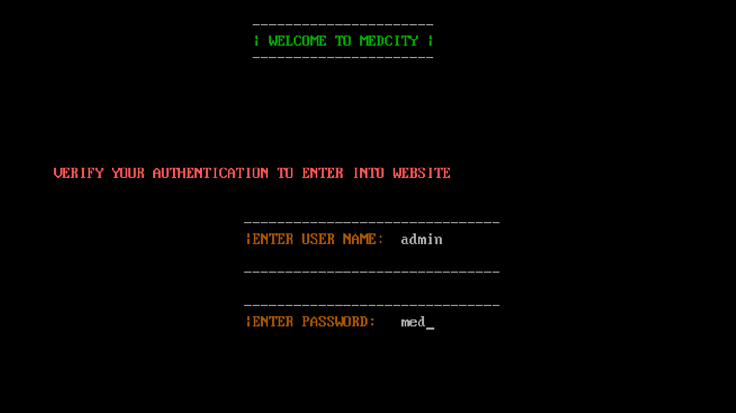

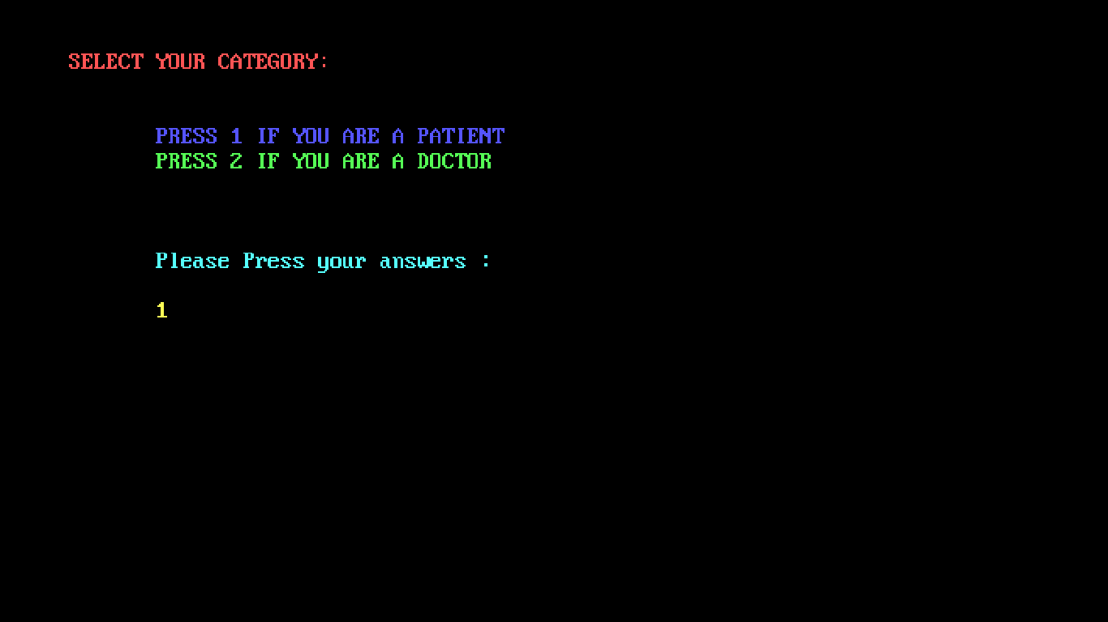

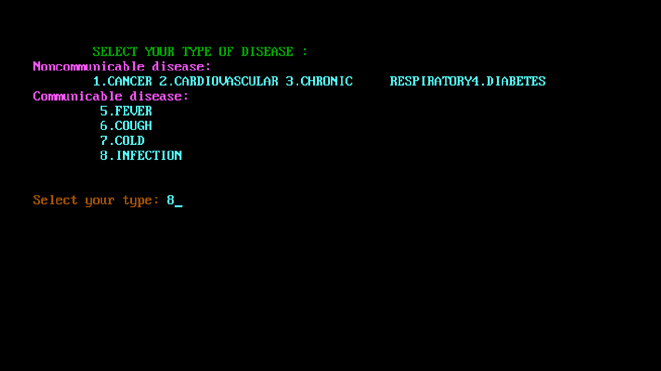

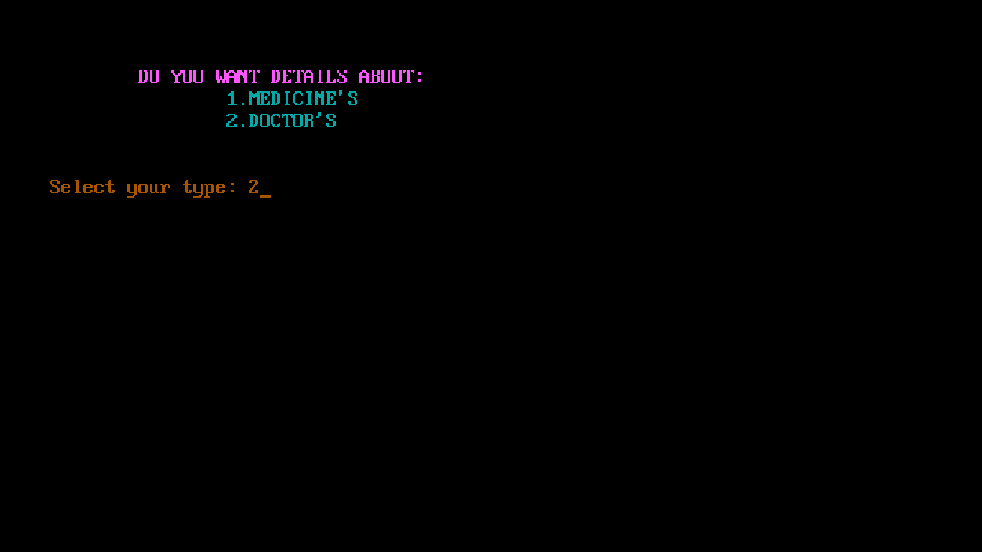

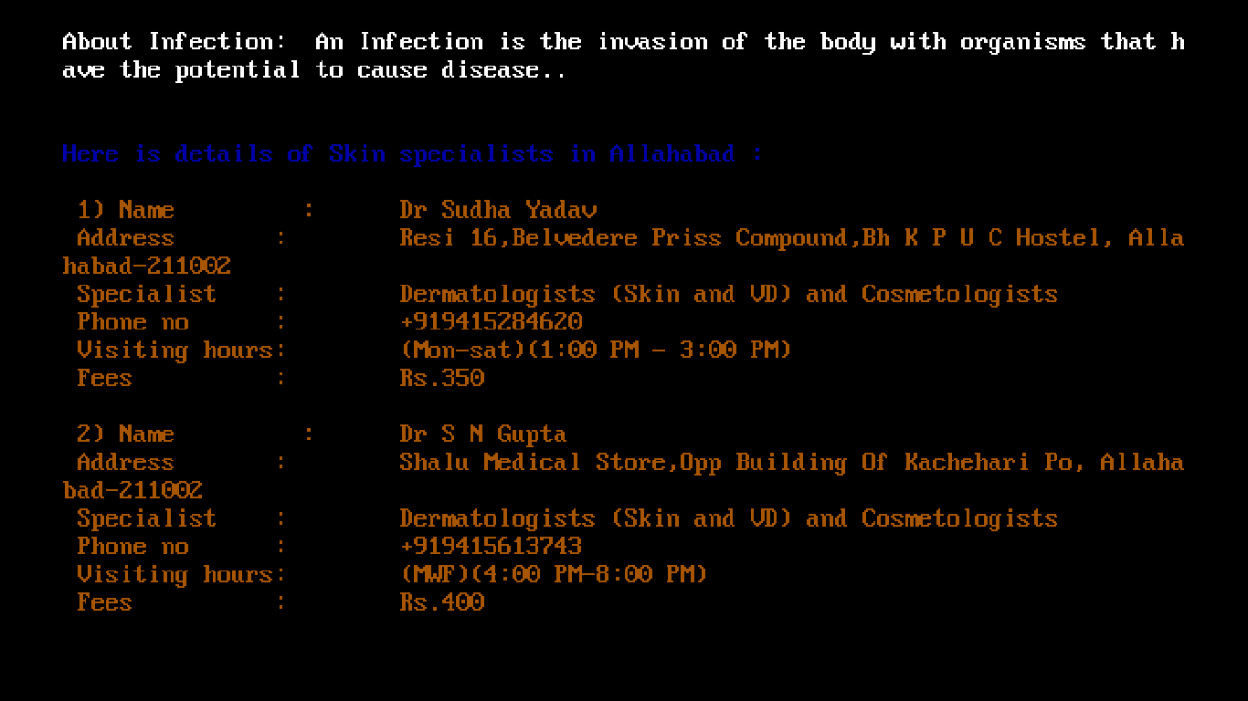

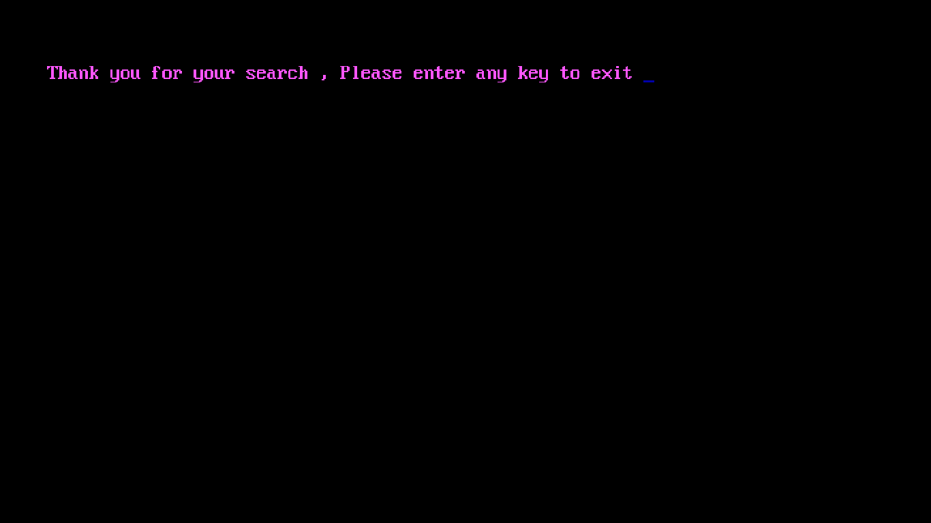

**CONTENT**

|  |  |  |
| --- | --- | --- |
| S.No. | Title | Page No. |
| 1. | Certificate of Excellence |  |
| 2. | Acknowledgement |  |
| 3. | Introduction |  |
| 4. | Header Files Included |  |
| 5. | Functions Used |  |
| 6. | Source Code |  |
| 7. | Screenshots |  |
| 8. | Conclusion |  |
| 9. | Future Scope |  |
| 10. | Bibliography |  |

**INTRODUCTION**

Today the world's most forward-looking medical agency are trying to provide more reliable and accurate services in medical field, offering services to the customers with all the available choices in their interest. It may be a leading many different medical shops. Every Shop nowadays is trying to computerize its activities to provide better services to its customers. The aim is to automate its existing manual system by the help of computerized equipments and full-fledged computer software, fulfilling their requirements, so that their valuable data/information can be stored for a longer period with easy accessing and manipulation of the same. This project, “MEDICAL DOSSIER SYSTEM” also a step towards offering more or less the similar features. This system enables to manage and record the activities of whole medical information of multi-facility skills only. It enables to provide their services in a more systematic and efficient manner, hence improving the goodwill of concerned institution. This can helps the administrator to analyze upon the performance of institution. This system organize their daily activities.

**HEADER FILES USED**

1. iostream.h
2. conio.h
3. stdio.h
4. string.h
5. process.h
6. stdlib.h
7. graphics.h
8. bclr.h
9. dos.h

**FUNCTIONS USED**

1.void page1(void)

2.void page2(void)

3.void page3(int)

4.void med(int,int)

5.void doc(int,int)

6.void cancer(int)

7.void heart(int)

8.void respiratory(int)

9void diabetes(int)

10.void fever(int)

11.void cough(int)

12.void cold(int)

13.void infection(int)

14.int main()

**CONCLUSION**

Medical Dossier System is an application project developed for medical geeks. This system is a field concerned with purchasing medicines, maintaining their info and all information about diseases and their doctor . It requires more time and effort when all procedures are performed manually.

Thus, in order to reduce time consumption and human effort the Medical Dossier System application can be applied in medicals where manual procedure exists.

The purpose of this project is to reduce time consumption and human effort. This application provides user friendly interface as well.

**FUTURE SCOPE**

1.Android App can be made.

2.It can be expanded and be used in medical stores.

**BIBLIOGRAPHY**

1. https:www.google.co.in
2. **http:www.medindia.net**
3. **http:www.firstaidforfree.com**
4. **http:www.homeveda.com**
5. **http:www.healthvault.com**